Ideation Phase

Define the Problem Statements

Date | 2-11-2025
Team ID | NM2025TMID03501
Project Name | Educational Organisation Using ServiceNow
Maximum Marks | 2 Marks

Defining Problem Statements in the Ideation Phase
The ideation phase is all about generating a wide range of creative ideas to address specific challenges. However, before you can brainstorm effective solutions, you must clearly define the problem you're trying to solve. A well-articulated problem statement acts as a compass, guiding your ideation efforts and ensuring that the solutions you develop are relevant and impactful. Without it, you risk creating solutions for non- existent problems or missing the root cause entirely.

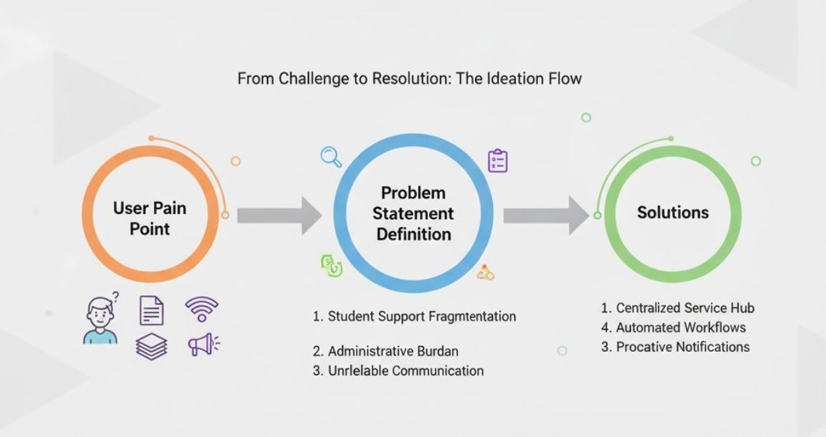

Student Services and Support Fragmentation

Customer (User) Problem Statement | Core Challenge | ServiceNow Solution
"Students are frustrated and often miss  deadlines because they don't know who to contact or where to find accurate information when they have an issue that crosses multiple departments (e.g.,  financial aid,  registration, housing, and IT)." | The institution lacks a single, unified point of  contact (a "front door") for all  student support services, leading to confusion,  dropped cases, and inefficiency. | ServiceNow Customer Service Management (CSM)  / Employee Center Pro. Implement a centralized Student Service Portal (or Employee Center) that acts as the single entry point for all inquiries. Use Service Catalog items to guide  students to the correct department automatically, and use Case Management to track their issue across departments without the  student having to re-explain their problem. Implement a Virtual Agent for instant, 24/7 answers to common  questions, deflecting up to 30% of simple inquiries.

Faculty/Staff Administrative Burden

Customer (User) Problem Statement | Core Challenge | ServiceNow Solution
"Faculty and staff spend too much time on manual, paper- based administrative  tasks, like processing grant applications, | Inefficient, siloed, and often manual back-office workflows create excessive  administrative | ServiceNow HR Service Delivery (HRSD) and Workflow Automation. Use Flow Designer to digitize  and automate cross- departmental workflows

Customer (User) Problem Statement | Core Challenge | ServiceNow Solution
submitting HR forms, or approving travel requests, taking time away from teaching and research." | friction, driving up operational costs and causing long approval delays. | (HR, Finance, Grant Administration). For  instance, an expense report can automatically route through a complex approval chain (Department Head  $\rightarrow$ Finance  $\rightarrow$ Dean) without human intervention. The Employee Center provides a simple, self-service interface for all forms, eliminating the need for paper and email  chains, leading to faster approvals and better compliance tracking.

